**S-100 – Part 2a**

Concept and Data Dictionary Registers

Summary of Substantive Changes in Edition 5.2.0

|  |  |
| --- | --- |
| Change Summary | Clauses Effected |
| **Part 2a – Concept and Data Dictionary Registers** | |
|  |  |
|  |  |

Contents

2a-1 Scope 1

2a-1.1 Conformance 1

2a-2 Normative references 1

2a-3 General concepts 2

2a-3.1 Register 2

2a-3.2 Relationship to the ISO Register and Feature Concept Dictionary Models 2

2a-3.3 Concept Register 3

2a-3.4 Data Dictionary Register 3

2a-3.5 Feature Catalogue 4

2a-4 IHO Concept and Data Dictionary Registers 4

2a-4.1 Detail of registered items 4

2a-4.1.1 IHO Concept Register 4

2a-4.1.2 IHO Data Dictionary Register 4

2a-4.2 Data model of the IHO Concept and Data Dictionary Registers 5

2a-4.2.1 UML Model 5

2a-4.2.2 S100_RE_Register 7

2a-4.2.3 S100_CD_RegisterItem 7

2a-4.2.4 S100_CD_Feature 7

2a-4.2.5 S100_CD_FeatureUseType 7

2a-4.2.6 S100_CD_Attribute 8

2a-4.2.7 S100_CD_SimpleAttribute 8

2a-4.2.8 S100_CD_QuantitySpecification 9

2a-4.2.9 S100_CD_AttributeValueType 10

2a-4.2.10 S100_CD_AttributeConstraints 11

2a-4.2.11 S100_CD_ComplexAttribute 11

2a-4.2.12 S100_CD_AttributeUsage 12

2a-4.2.13 S100_CD_EnumeratedValue 12

2a-4.2.14 S100_CD_Information 12

2a-4.2.15 S100_Concept 13

Appendix 2a – A – Example of a complex attribute (informative) 15

Page intentionally left blank

# Scope

The IHO Geospatial Information (GI) Registry contains a number of Registers, some of which are based on the contents of the Concept Register. The Concept Register specifies hydrographic core conceptual information (definitions, camelCase, etc) that may be used to describe geographic or meta data information. The use of a Register to store hydrographic definitions significantly improves the IHOs ability to manage and extend multiple products based on S-100 which can be made available for use in a relatively short timescale. As such, the Register supports wider use of registered items by making them publicly available; and increases their visibility to potential users. The Concept Register is the primary resource where all registered concepts are stored and managed as “stateless” concepts (that is, items are not assigned a type and there is no defined binding of concepts to other concepts within the Register). Each concept shall be included as a single instance in the Register and will be used as the common source from which Data Dictionary Register and Meta Data Register concepts are derived and used to model features, attributes etc. for use in S-100 based Product Specifications.

The Data Dictionary Register expands on the concepts stored in the Concept Register by including the assignment of item types and feature binding in discrete Domains within the Register. This allows S-100 based Product Specification developers to develop their data models to best suit their specific requirements for representation of the real world.

This Part describes the content of the Concept and Data Dictionary Registers and specifies procedures to be followed in establishing, maintaining, and publishing Registers of unique, unambiguous and permanent identifiers that are assigned to items of geographic, hydrographic and metadata information. In order to accomplish this purpose, this Part specifies elements of information that are necessary to provide identification and definitions to the registered items.

## Conformance

This profile conforms to conformance class 2 of ISO 19106:2004. The following is a brief description of the specializations and generalizations where the profile differs from ISO 19126:2008.

1. A new class, S100_CD_Information is introduced.
2. New classes, S100_CD_Feature and S100_CD_Information are introduced.
3. A new class, S100_CD_AttributeConstraints is introduced.
4. The class FC_FeatureAttribute is specialized to be the abstract class *S100_CD_Attribute*.
5. New classes, S100_CD_SimpleAttribute and S100_CD_ComplexAttribute are introduced.
6. The classes CD_InheritanceRelation, CD_FeatureOperation CD_Binding, CD_Constraint and CD_BoundFeatureAttribute are not used.

# Normative references

The following referenced documents are required for the application of this document. For dated references, only the edition cited applies. For undated references, the latest edition of the referenced document (including amendments) applies.

ISO 19135:2005, *Geographic Information – Procedures for registration of items of geographic information*

ISO 19126:2009, *Geographic Information – Feature concept dictionaries and registers*

ISO 8601:2004, *Data elements and interchange formats - Information interchange - Representation of dates and times*

ISO/IEC 10646:2017, *Information Technology – Universal Coded Character Set (UCS)*

RFC 3986, *Uniform Resource Identifier (URI): Generic Syntax*. T. Berners-Lee, R. Fielding, L. Masinter. Internet Standard 66, IETF. URL: <http://www.ietf.org/rfc/rfc3986.txt> or <http://www.rfc-editor.org/info/std66>

RFC 2141, *URN Syntax*. R. Moats. IETF RFC 2141, May 1997. URL: <https://www.ietf.org/rfc/rfc2141.txt>

W3C *XML Schema Part 2: Datatypes* Second Edition, Appendix F *Regular Expressions*. URL: [https://www.w3.org/TR/xmlschema-2/#regexs](https://www.w3.org/TR/xmlschema-2/" \l "regexs)

# General concepts

## Register

As described in Part 2, a Register is simply a managed list. It is easier to maintain than a fixed document, because new items can be added as needed to the Register, and existing items in the Register can be clarified, superseded or retired. Each Register item has one or more dates associated with it that indicate when changes in its status occurred. This means that a Product Specification, defined at a given date, may reference an item in the Register at that specific point in time.

## Relationship to the ISO Register and Feature Concept Dictionary Models

The realization of ISO 19126 and ISO 19135 types in the IHO GI Registry is shown in Figure 2a-1 below. This Figure depicts the ISO types (elements with grey backgrounds); the implemented S-100 Registry model classes (elements with tan backgrounds); and two of the Registers comprising the IHO GI Registry (elements with white backgrounds). The Registers themselves are implemented within different sections of the IHO GI Registry web site, each accessible through a site navigation menu.

The ISO type “Feature Concept Dictionary”, which contains definitions of feature and attribute types, is implemented as the “Data Dictionary Register” in the IHO GI Registry (S100_DataDictionaryRegister in Figure 2a-1). The Data Dictionary Register contains definitions of features, information types, attributes (both simple and complex), and enumerated values for enumeration and S100_Codelist attributes (see S-100 Part 1, clauses 1-4.7 and 1-4.8). The Data Dictionary Register is further described in clauses 2a-3.4 and 2a-4.1.2.

The IHO GI Registry also implements a “Concept Register” (S100_ConceptRegister in Figure 2a-1), which can be understood as a kind of glossary of terms with definitions and sources. Individual entries in the Concept Register are represented by the class S100_Concept. The Concept Register is separate from the Data Dictionary Register. However, entries in the Data Dictionary Register are derived from entries in the Concept Register. The Concept Register is further described in clauses 2a-3.3 and 2a-4.1.1.

Registers for associations and roles are not currently implemented within the IHO GI Registry and the corresponding ISO types are therefore not included in Figure 2a-1. Also, the IHO GI Registry includes additional Registers (for Portrayal, Producer Codes, Product Specifications, and Metadata) which are not shown in Figure 2a-1.

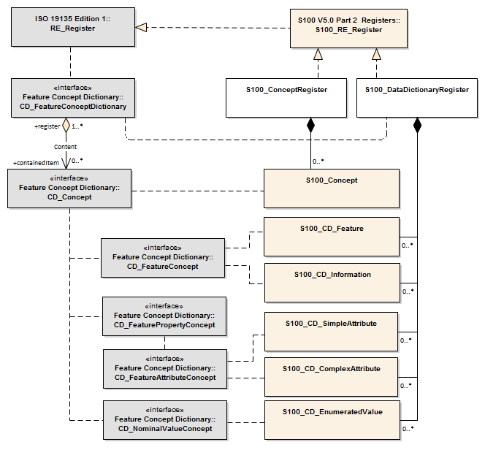

Figure 2a-1 – Relationships of the S-100 Registry Classes to ISO 19126/ISO 19135 Model

## Concept Register

A Concept Register specifies unique, independent sets of definitions of concepts that may be used to describe geographic, hydrographic, and metadata information. These concepts as registered in a Concept Register may then be used within a Data Dictionary or Meta Data Register to develop a Feature Catalogue. Unlike a Data Dictionary Register, a Concept Register does not make associations; or define type or bindings of concepts to other concepts. From this perspective, registered items within the Concept Register are essentially “stateless”, which allows for flexibility of the use of the concepts for suitable data modelling to satisfy the requirements of Product Specifications.

Such Registers of geospatial information may serve as sources of reference for similar Registers established by other geographic information communities as part of a system of cross-referencing.

## Data Dictionary Register

A Data Dictionary Register specifies independent sets of definitions of features, attributes, enumerated values, and information types that may be used to describe geographic, hydrographic, and metadata information. A Data Dictionary Register may be used to assign an item defined in a Concept Register a type (for example feature, attribute and enumerate value); and define recommended associations and attribute/feature bindings to facilitate the development of Feature Catalogues. Items in a Concept Register can only be registered once against each type in a Data Dictionary Register in order to support interoperability.

Such Data Dictionaries of geospatial information may serve as sources of reference for similar Data Dictionaries or Registers established by other geographic information communities as part of a system of cross-referencing.

## Feature Catalogue

A Feature Catalogue is a document that describes the content of a data product. It uses item types, for example features and attributes, from one or more Data Dictionaries and binds them together. In addition constraints, units of measurement and format description of attributes can be specified. Feature Catalogues are described in detail in S-100 Part 5.

# IHO Concept and Data Dictionary Registers

## Detail of registered items

### IHO Concept Register

The following are the details available in a Concept Register to describe and manage hydrographic, marine-related and meta data information:

1. Item Name
2. Item Identifier
3. Item Status
4. Alias
5. Camel Case
6. Definition
7. Definition Source
8. Definition Reference
9. Similarity to Source
10. Remarks
11. Proposal Type
12. Successor
13. Predecessor
14. Submitting Organization
15. Date Proposed
16. Date Accepted
17. Date Amended
18. Proposed Change
19. Justification

These details are derived from the classes S100_RE_RegisterItem and S100_RE_ManagementInfo (see clause 2a-4.2 below and Part 2, clauses 2-8.3 and 2-8.8).

### IHO Data Dictionary Register

The following are types of items, as derived from a Concept Register, which may be registered within a Data Dictionary Register:

1. Feature – abstraction of real world phenomena.
2. Attribute – characteristic of a feature concept.
3. Enumerated Value – one of a set of mutually exclusive values constituting the domain of an attribute.
4. Information – an identifiable object that contains attributes, associations to other information concepts, but no spatial information.
5. Codelist – an open enumeration, or the identifier of a vocabulary (mapping between codes, labels and definitions).

## Data model of the IHO Concept and Data Dictionary Registers

### UML Model

The following Figure shows the UML information model of the IHO Concept and Data Dictionary Registers:

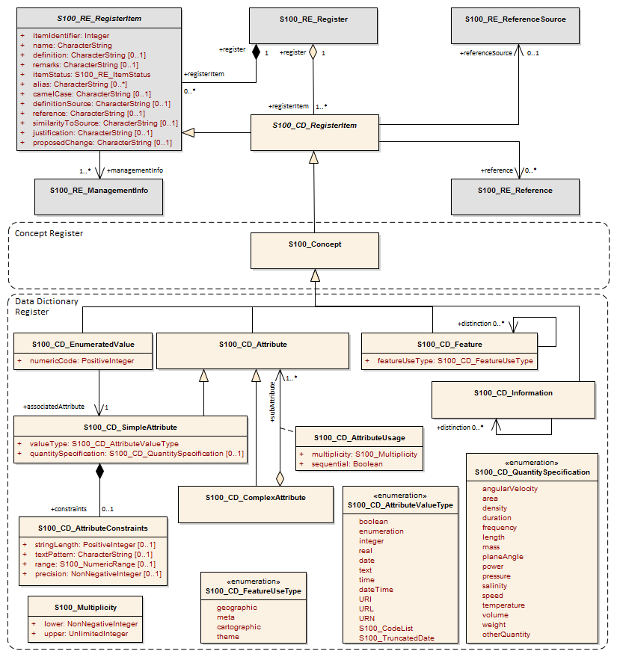

Figure 2a-2 – IHO Concept and Data Dictionary Registers

Page intentionally left blank

### S100_RE_Register

The class S100_RE_Register models a Register in a Registry. Further details can be found in S-100 Part 2, clause 2-8.2.

### S100_CD_RegisterItem

The class S100_CD_RegisterItem is a specialization of the class S100_RE_RegisterItem and carries the characteristics that are common to all types of registered items listed in clause 2a-4.1.1. This class is included in the model for consistency with Part 2b, in which a similar extension (S100_PR_RegisterItem) defines additional attributes.

|  |  |  |  |  |  |
| --- | --- | --- | --- | --- | --- |
| Role Name | Name | Description | Mult | Type | Remarks |
| Class | S100_CD_RegisterItem | Extension of S100_RE_RegisterItem | - | - | Abstract class |

### S100_CD_Feature

This class is derived from S100_RE_RegisterItem via intermediate super-classes. It defines the following additional properties:

|  |  |  |  |  |  |
| --- | --- | --- | --- | --- | --- |
| Role Name | Name | Description | Mult | Type | Remarks |
| Class | S100_CD_Feature | A feature type in a Data Dictionary | - | - | Derived from S100_Concept |
| Attribute | featureUseType | The intended use of a feature type | 1 | S100_CD_FeatureUseType |  |
| Association role | distinction | References to feature types that this feature type is distinct from | 0..* | S100_CD_Feature |  |
| Association | conceptReference | References S100_Concept as the base class | 1 | S100_Concept |  |

NOTE The attribute camelCase is mandatory for this class.

### S100_CD_FeatureUseType

|  |  |  |  |
| --- | --- | --- | --- |
| Item | Name | Description | Remarks |
| Enumeration | S100_CD_FeatureUseType | Categories of feature types |  |
| Literal | geographic | carries the descriptive characteristics of a real world entity |  |
| Literal | meta | Delineates geographic location where meta information is applicable” distinct from an Information Type which carries information related to features which are related |  |
| Literal | cartographic | carries information about the cartographic representation (including text) of a real world entity |  |
| Literal | theme | Grouping features thematically |  |

### S100_CD_Attribute

Attributes may either be simple or complex. A simple attribute carries a specific value such as a date. A complex attribute is an aggregation of other attributes either simple or complex. Examples of complex attributes are in Appendix 2a-A. This class is derived from S100_RE_RegisterItem via intermediate super-classes and describes the common characteristics of all attribute types.

|  |  |  |  |  |  |
| --- | --- | --- | --- | --- | --- |
| Role Name | Name | Description | Mult | Type | Remarks |
| Class | S100_CD_Attribute | Base class of all attribute types in a Data Dictionary | - | - | Derived from S100_Concept |
| Association | conceptReference | References S100_Concept as the base class | 1 | S100_Concept |  |

NOTE The attribute camelCase is mandatory for this class.

### S100_CD_SimpleAttribute

|  |  |  |  |  |  |
| --- | --- | --- | --- | --- | --- |
| Role Name | Name | Description | Mult | Type | Remarks |
| Class | S100_CD_SimpleAttribute | A simple attribute type in a Data Dictionary | - | - | Derived from S100_CD_Attribute |
| Attribute | valueType | Describes representation, interpretation and structure of values | 1 | S100_CD_AttributeValueType | See below |
| Attribute | quantitySpecification | Specification of the quantity, for example length, volume, depth, weight etc | 0..1 | S100_CD_QuantitySpecification |  |
| Association | constraints | Constraints of the attribute type | 0..1 | S100_CD_AttributeConstraints | Must be consistent with dataType |

If the *valueType* is S100_Codelist exactly one of the following must be true:

1. There is an associated S100_RE_Reference with the namespace of a dictionary that is listed in the IHO GI Registry.
2. There is at least one S100_CD_EnumeratedValue associated to the attribute.

Condition 1 identifies the dictionary for codelists of type “open dictionary” or “closed dictionary”. Condition 2 provides the enumerated value(s) for codelists of type “open enumeration”. The precise codelist type is determined in individual Product Specifications.

### S100_CD_QuantitySpecification

| Item | Name | Description | Remarks |
| --- | --- | --- | --- |
| Enumeration | S100_CD_QuantitySpecification | Types of quantity measures | Adapted from ISO 19103 Measure Types |
| Literal | angularVelocity | The instantaneous rate of change of angular displacement with time | From ISO 19103 |
| Literal | area | The measure of the physical extent of any two-dimensional geometric object | From ISO 19103 |
| Literal | density | Mass per unit volume; number per unit area. Also: specific gravity (S-32). Density of soundings is the intervals between lines of sounding and soundings in the same line (S-32) | “Density” can be used in different senses, the unit of measure and attribute definition must make it clear which is intended |
| Literal | duration | Interval of time |  |
| Literal | frequency | Number of vibrations or cycles per unit time | IHO S-32 |
| Literal | length | The longest dimension of an object; distance measured along a line or curve |  |
| Literal | mass | A numerical measure of the inertia of an object; the quantity of matter which a body contains, irrespective of its bulk or volume |  |
| Literal | planeAngle | The amount of rotation needed to bring one line or plane into coincidence with another, generally measured in radians or degrees | From ISO 19103 “angle” |
| Literal | power | Rate of doing work or transferring energy; magnification | S-32 refers “power” to “magnifying power: the ratio of the apparent length of a linear dimension as seen through an optical instrument to that seen by the unaided eye”. The unit of measure and attribute definition must make it clear which sense is intended |
| Literal | pressure | Force per unit area |  |
| Literal | salinity | A measure of the quantity of dissolved salts | IHO S-32 (abbrev.) |
| Literal | speed | Rte of change of position with time | Usually calculated using the simple formula, the change in position during a given time interval. Speed is a scalar physical quantity, having magnitude but not direction. Contrast to “velocity” which is a vector quantity having both magnitude and direction. (Adapted from ISO 19103 “velocity”) |
| Literal | temperature | The intensity or degree of heat | IHO S-32 |
| Literal | volume | The measure of the physical space of any 3-D geometric object | From ISO 19103 |
| Literal | weight | The force experienced by an object due to gravity |  |
| Literal | otherQuantity | A quantity different from the other literals of this enumeration |  |

### S100_CD_AttributeValueType

|  |  |  |  |
| --- | --- | --- | --- |
| Item | Name | Description | Remarks |
| Enumeration | S100_CD_AttributeValueType | Value types of simple attributes |  |
| Literal | boolean | True or False |  |
| Literal | enumeration | List of predetermined values that can be expanded and contracted |  |
| Literal | integer | Numeric value with defined range, units and format |  |
| Literal | real | Floating point number |  |
| Literal | text | A sequence of characters |  |
| Literal | date | Character encoding shall follow the format for date as specified by ISO 8601 |  |
| Literal | time | Character encoding shall follow the format for time as specified by ISO 8601 |  |
| Literal | dateTime | Character encoding shall follow the format for date and time as specified by ISO 8601 |  |
| Literal | URI | Character encoding shall follow the format for URI as specified by RFC 3986 |  |
| Literal | URL | Character encoding shall follow the format for URL as specified by RFC 3986 |  |
| Literal | URN | Character encoding shall follow the format for URN as defined by RFC 2141 |  |
| Literal | S100_CodeList | Open enumeration or identifier of entry in a vocabulary |  |
| Literal | S100_TruncatedDate | Truncated format for date |  |

### S100_CD_AttributeConstraints

|  |  |  |  |  |  |
| --- | --- | --- | --- | --- | --- |
| Role Name | Name | Description | Mult | Type | Remarks |
| Class | S100_CD_AttributeConstraints | Constraints of a simple attribute | - | - |  |
| Attribute | stringLength | Shall be represented as a positive integer (that is, greater than zero) that specifies the maximum number of characters that may be assigned to the text attribute type. If not specified, then the text length shall be unconstrained | 0..1 | PositiveInteger |  |
| Attribute | textPattern | A character string that specifies a scheme of one or more constraints on the structure of the text values that may be assigned to the attribute. This shall be achieved by using a regular expression. W3C XML Schema Part 2: Datasets Second Edition, Appendix F (Regular Expressions) shall be used to define text patterns in this standard | 0..1 | CharacterString |  |
| Attribute | range | Specifies the range of allowed numeric values | 0..1 | S100_NumericRange |  |
| Attribute | precision | Specifies the precision of a real number | 0..1 | NonNegativeInteger |  |

### S100_CD_ComplexAttribute

|  |  |  |  |  |  |
| --- | --- | --- | --- | --- | --- |
| Role Name | Name | Description | Mult | Type | Remarks |
| Class | S100_CD_ComplexAttribute | A complex attribute type in a Data Dictionary | - | - | Derived from S100_CD_Attribute |
| Association | subAttribute | References the sub attribute | 1..* | S100_CD_Attribute | Characteristics defined by S100_CD_AttributeUsage |

### S100_CD_AttributeUsage

This class specifies the characteristics of the association between a complex attribute type and its sub attributes.

|  |  |  |  |  |  |
| --- | --- | --- | --- | --- | --- |
| Role Name | Name | Description | Mult | Type | Remarks |
| Class | S100_CD_AttributeUsage | Characteristics of the association between a complex attribute and its sub attributes | - | - |  |
| Attribute | multiplicity | Number of occurrences of the sub attribute | 1 | S100_Multiplicity |  |
| Attribute | sequential | Boolean value that indicates if the sub attributes of a complex attribute are in a particular order | 1 | Boolean | It is only applicable if a sub attribute has multiplicity > 1 |

### S100_CD_EnumeratedValue

This class is derived from S100_RE_RegisterItem via intermediate super-classes and describes the characteristics of an enumerated value type.

|  |  |  |  |  |  |
| --- | --- | --- | --- | --- | --- |
| Role Name | Name | Description | Mult | Type | Remarks |
| Class | S100_CD_EnumeratedValue | Characteristics of an enumerated value type in a Data Dictionary | - | - |  |
| Attribute | numericCode | A positive integer designating the unique value in the domain | 1 | PositiveInteger |  |
| Association | associatedAttribute | Specifies the attribute type item for which this is a domain value | 1 | S100_CD_SimpleAttribute | Applies only where class S100_CD_SimpleAttribute attribute valueType = *enumeration* or *S100_CodeList* |
| Association | conceptReference | References S100_Concept as the base class | 1 | S100_Concept |  |

### S100_CD_Information

|  |  |  |  |  |  |
| --- | --- | --- | --- | --- | --- |
| Role Name | Name | Description | Mult | Type | Remarks |
| Class | S100_CD_Information | Characteristics of an information type in a Data Dictionary | - | - |  |
| Association | distinction | Similar information types that this is distinct from | 0..* | S100_CD_Information |  |
| Association | conceptReference | References S100_Concept as the base class | 1 | S100_Concept |  |

NOTE The attribute camelCase is mandatory for this class.

### S100_Concept

The class S100_Concept identifies the required information for the Concept Register. Further details can be found in clause 2a-3.3.

|  |  |  |  |  |  |
| --- | --- | --- | --- | --- | --- |
| Role Name | Name | Description | Mult | Type | Remarks |
| Class | S100_Concept | A definition of object, information or phenomena of nature | - | - |  |

# Appendix 2a – A

# Example of a complex attribute (informative)

NOTE: The following example does not reflect the modelling of lights in any S-100 based Product Specification.

A light may have several sectors. All of them share the same light characteristic and sequence. Other common attributes are the height and the name.

All attributes describing one sector in a complex attribute are structured “Light sector”.

A complex attribute for the “Rhythm of light” is also defined.

The simple attributes used in “lightSector” are:

* sectorLimit1 (type Real)
* sectorLimit2 (type Real)
* colour (type Enumeration)
* valueOfNominalRange (type Real)

Therefore the complex attribute is:

|  |  |  |
| --- | --- | --- |
| Characteristic | Value | |
| name | Light sector | |
| definition | A sector is the part of a circle between two straight lines drawn from the centre to the circumference. (Advanced Learner’s Dictionary, 2nd Edition). | |
| remarks | n/a | |
| camelCase | lightSector | |
| alias | LITSEC | |
| **Sub Attributes** | **Attribute Binding** | |
| **camelCase Identifier** | **multiplicity** | **sequential** |
| sectorLimit1 | 1 | n/a |
| sectorLimit2 | 1 | n/a |
| colour | 1 | n/a |
| valueOfNominalRange | 0..1 | n/a |

Note: The multiplicity and sequence are carried in the attribute between the complex and sub-attribute.

The “Rhythm of light” consists of:

* lightCharacteristic
* signalPeriod
* signalGroup

|  |  |  |
| --- | --- | --- |
| Characteristic | Value | |
| name | Rhythm of light | |
| definition |  | |
| remarks | n/a | |
| camelCase | rhythmOfLight | |
| alias | RHYLGT | |
| **Sub Attributes** | **Attribute Binding** | |
| **camelCase Identifer** | **multiplicity** | **sequential** |
| lightCharacteristic | 1 | n/a |
| signalPeriod | 0..1 | n/a |
| signalGroup | 0..1 | n/a |

A second way of describing the rhythm of light is the “signal sequence” as it is done with the S-57 SIGSEQ attribute. A signal sequence consists of intervals where the signal is either on or off (here light or eclipse)

|  |  |  |
| --- | --- | --- |
| Characteristic | Value | |
| name | Signal sequence interval | |
| definition | tbd. | |
| remarks | n/a | |
| camelCase | signalSequenceInterval | |
| alias | SGSQIN | |
| **Sub Attributes** | **Attribute Binding** | |
| **camelCase Identifer** | **multiplicity** | **sequential** |
| signalStatus | 1 | n/a |
| duration | 1 | n/a |

A Signal sequence is then just an ordered list of those intervals.

|  |  |  |
| --- | --- | --- |
| Characteristic | Value | |
| name | Signal sequence | |
| definition | The sequence of times occupied by intervals of light and eclipse for all “light characteristics”. (Adapted from S-57 Edition 3.1, Appendix A – Chapter 2, Page 2.191, November 2000). | |
| remarks | n/a | |
| camelCase | signalSequence | |
| alias | SIGSEQ | |
| **Sub Attribute** | **Attribute Binding** | |
| **camelCase Identifier** | **multiplicity** | **sequential** |
| signalSequenceInterval | 1..* | True |

A light object would now consist of:

Light:

* rhythmOfLight [1..*]
* lightSector [1..*]
* signalSequence [0..1]
* objectName[0..1]
* height[0..1]

This definition would be included in the Feature Catalogue, although the definition of the attributes are derived from the Concept Register.